CENTURION UNIVERSITY • NATIVE & INDIGENOUS SPORTS INITIATIVE
GAME PITCH PROPOSAL
CHAUPAD — THE CLOTH CROSS RACE
(चौपड़ / ଚୌପଡ଼)
Pachisi’s Courtly Sibling: Reclaiming India’s Royal Strategy Heritage for the Global Open Web
Project Pitch & Commercial Feasibility Document • Production Release v1.0
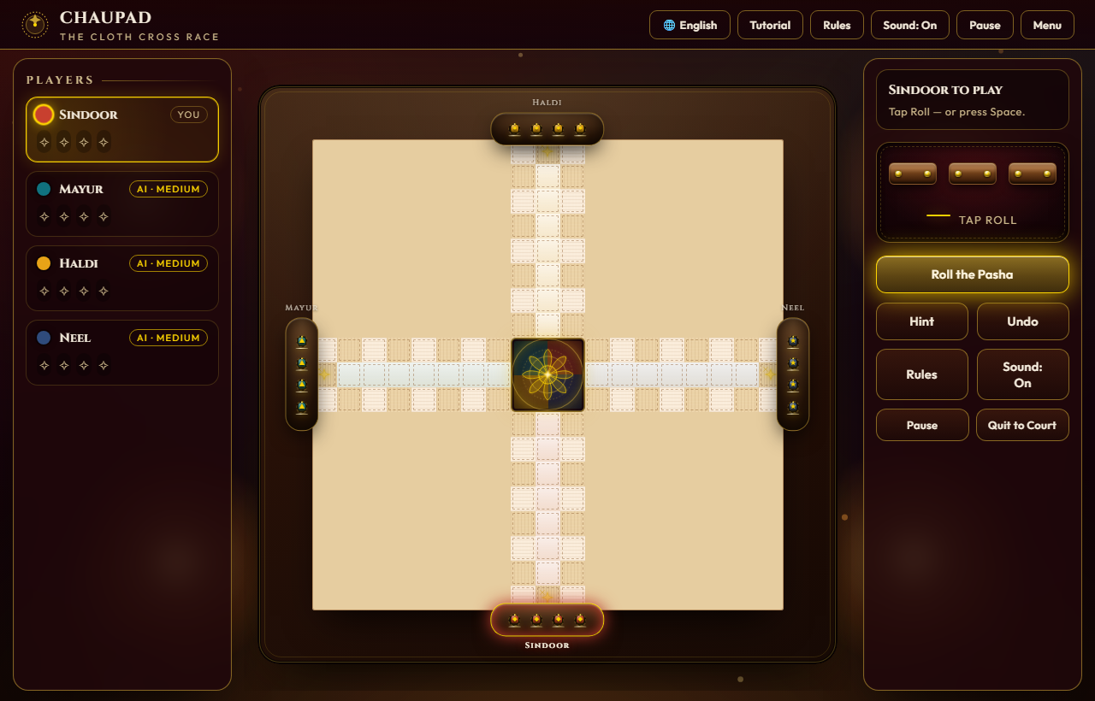
Figure 1: Authentic In-Game Desktop View — Zardozi Velvet Cloth Board, Pasha Long-Dice, and Multilingual Court HUD.
Project Title | Chaupad (Chaupar / Chausar) — The Cloth Cross Race
Project Team | Arbaz Arshad (Lead Developer & Systems Architect) • CUTM Indigenous Sports Lab
Genre & Platform | Turn-Based Heritage Board Strategy • Cross-Platform Web (HTML5/Canvas/Mobile PWA)
Target Audience | Casual strategy board gamers, Indian diaspora, schools, cultural heritage institutions (Ages 8+)
Development Stack | Pure Vanilla Web Stack (HTML5, Canvas 2D, SVG, CSS3, ES6 JavaScript) — Zero Dependencies
Commercial Status | Production Ready (Automated 500-Game Monte Carlo Headless Test Suite Passed)

2. Executive Summary
Chaupad (historically celebrated in Emperor Akbar’s Ain-i-Akbari and Rajput miniatures) is India’s classical cruciform cloth-and-dice race game. While the Western world is familiar with its simplified descendant, Ludo, modern gaming has completely lost touch with the profound tactical majesty of original Chaupad: the authentic three-stick wooden long-dice (pasha), the strategic sanctuary of eight castle squares, the defensive power of Thappi pawn stacking, and the cooperative brilliance of 2v2 court partnerships. Our project resurrects this cultural masterpiece into a state-of-the-art open-web game.
Engineered with a strict zero-dependency philosophy (pure HTML5, Canvas 2D, SVG, and modern ES6), the application delivers instantaneous sub-220ms cold loads across mobile phones, tablets, and desktop browsers without installation. Featuring an opulent Mughal-Rajput zardozi aesthetic, trilingual localization (English, Hindi, Odia), 3 calibrated AI tiers, and empirical balance verified across 500 automated headless matches, Chaupad is uniquely positioned to bridge centuries of Indian gaming heritage with viral open-web accessibility.

3. Game Description

a. Overview
Chaupad is a turn-based cross-and-circle heritage race game played on a four-armed embroidered cloth cross. Four Royal Houses (Sindoor / South, Mayur / West, Haldi / North, Neel / East) compete to race their four conical wooden pieces (gothi) around a 72-cell outer perimeter, make an inward turn into their private home column, and enter the central sacred sanctuary—the Charkoni Lotus. Matches can be played 1P vs Bots, 2-4P local Pass & Play, or in 2v2 royal partnerships.

b. The Quest & Objectives
The quest begins at each player's consecrated gate. Players roll three long-dice (pasha) to advance tokens counter-clockwise around the outer circuit. Obstacles include enemy combatants that can strike lone pieces back to the gate, and strategic bottlenecks on narrow arm columns. Rewards include bonus throws on high double/triple rolls (Chau / चौ) and safe passage through the 8 Castle sanctuaries. The final objective is bearing all four pieces into the Charkoni Lotus by exact dice count.

c. Main Characters & Tokens (Gothi & Thappi)
The primary actors are the conical lacquered wooden pawns (gothi). When isolated, a pawn is vulnerable to capture. However, when two or more friendly pawns occupy the same square, they fuse into a Thappi (shield-locked super-pawn). Super-pawns move as a unified squad, resist attacks from single enemy tokens, and can blockade narrow corridors, transforming the game from a simple race into a defensive escort.

d. Visual of Pieces & Board Environment
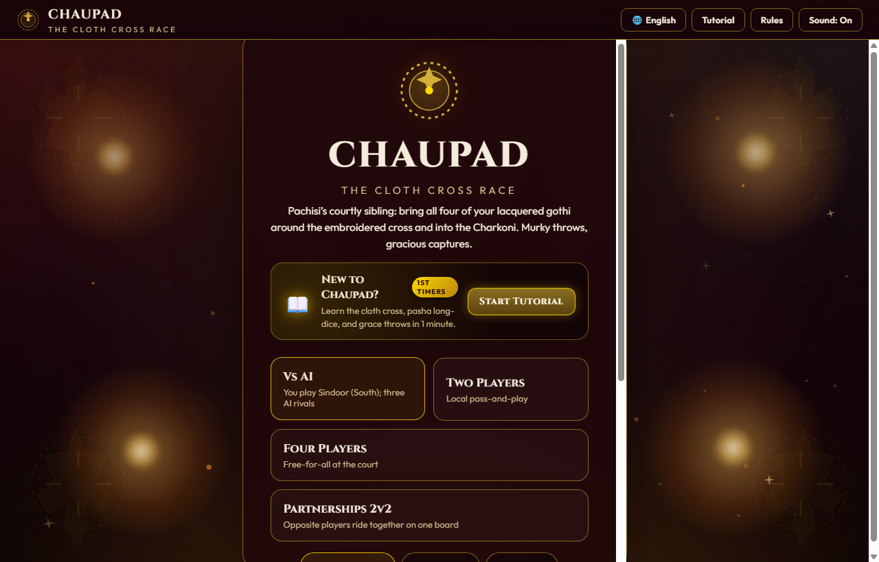
Figure 2: The Royal Court Foyer — Single Language Selector (EN / HI / OR), AI Difficulty Tier, and Player Formats.

e. Opponents & Artificial Intelligence (AI)
The game features three intelligent bot calibres designed to challenge players across all skill levels:
• Apprentice (शिष्य / ଶିଷ୍ୟ): Greedy forward-mover; seizes obvious captures but leaves lone pieces exposed.
• Court Tactician (रणनीतिकार / ରଣନୀତିଜ୍ଞ): Uses a 5-variable utility function; balances captures (+75), safe castle retreats (+12), and Thappi stack formations (+40) while actively avoiding enemy strike vectors.
• Grand Vizier (महामंत्री / ମହାମନ୍ତ୍ରୀ): Master tactician; sets bait pieces, coordinates paired advances, and establishes blockades.

f. Environment & Art Direction
The aesthetic is inspired by 16th-century Mughal and Rajput courtly zardozi needlework. The board sits on a deep imperial velvet cloth (#14030a) embroidered with gold zari thread (#D4AF37) and dark teakwood borders (#2D120A). Ambient diya oil lamplight flickers softly across the corners, immersing players in a royal court pavilion.

g. Menus & User Interface
The UI consists of an ornate Court Foyer menu where players choose match formats (Solo vs Bots, Pass & Play, Team 2v2), select AI calibre, and pick their preferred language: English (en), हिन्दी (hi), or ଓଡ଼ିଆ (or). In-game, a dedicated topbar displays the crest, an interactive 5-step tutorial modal, sound toggles, and live turn indicators.
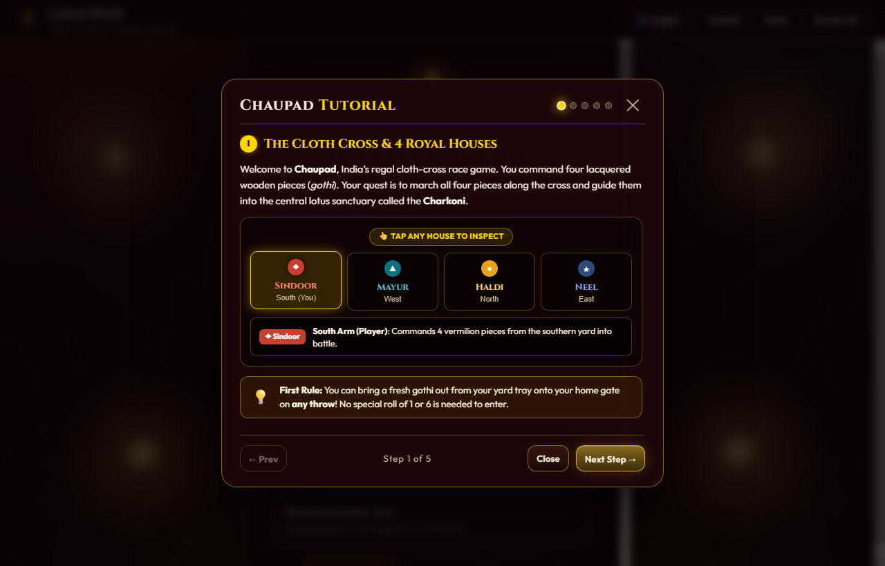
Figure 3: Interactive 5-Step Tutorial Modal — Explaining the Ancient Rules in the Player’s Chosen Language.

h. Controls & Touch Ergonomics
Designed mobile-first. On smartphones, the board auto-scales using CSS clamp(280px, 94vmin, 620px), while the Pasha roller and turn indicator dock into a floating bottom glassmorphism bar. All pawn touch targets have invisible 44px hit-boxes (.od-touch), ensuring effortless thumb play.
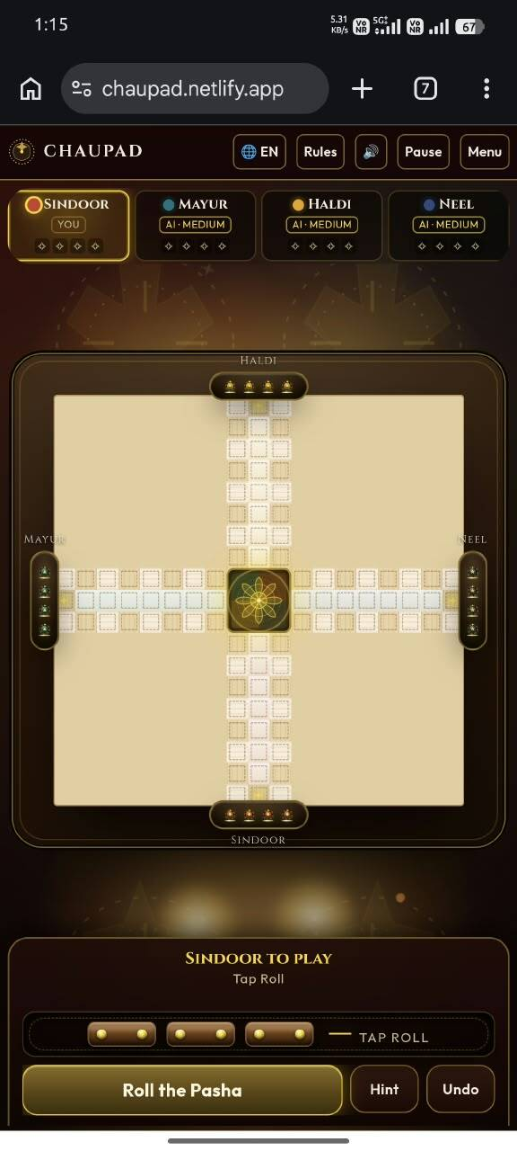
Figure 4: Mobile Ergonomics Polish — Responsive Board Scaling (94vmin), Bottom Touch Controls & Pristine Viewport.

i. Audio & Haptic Design
Utilizes the Web Audio API for zero-bandwidth synthesized sound effects: the dry rattling click of three wooden pasha sticks tumbling, a deep acoustic thud upon striking the velvet cloth, crisp capture tones, and a resonant royal brass gong upon victory.

4. Summary & The Commercial Pitch
Why invest in or adopt Chaupad?
1. Massive Cultural & Diaspora Market: Over 1.4 billion people in India and a 35-million-strong global diaspora hold deep nostalgic affection for heritage board games, yet 99% of digital offerings are generic, ad-choked Ludo clones. Chaupad provides an authentic, high-prestige alternative.
2. Zero-Friction Web Distribution: Requiring no app store download, no registration, and no installation, Chaupad can be instantly shared via a web link on WhatsApp, embedded into digital museum kiosks, or deployed across school Chromebooks in seconds.
3. Educational & Institutional Alignment: Endorsed by Centurion University (CUTM) and built upon rigorous historical scholarship, the game is primed for adoption by schools, cultural ministries, and heritage tourism platforms worldwide.

